Judging-She Taught Me By Example
September 15, 2026
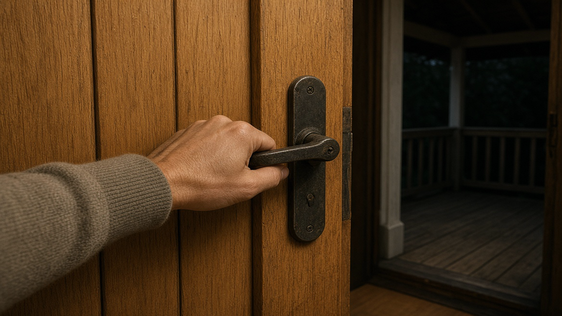
May we learn the ways of true peace in our lives. I want to share something with you that kind of reflects back on that last teaching about talking negatively, judging and self-righteousness. Building on that message which kind of highlighted complaining and judging and how it opens doors to demonic sifting and strife, I have a sweet touch to add on how the Lord is leading us in the ways of unconditional love and an absolute end to judging others.
It comes from a very special lady. I've had a bad habit of negativity, seeing sometimes the bad side of situations and and complaining about their so -called faults. How ridiculous that I was considering their faults when I've got so many of my own. You know how it is when you're married and someone rubs you the wrong way and you can tell your sympathetic and agreeing spouse about it and get so much negative reinforcement.
So you both now fall into the pit of judgment which opens every door and window in your house to the demons, which results in bickering, quarreling, misunderstanding, judgment about one another, mostly born of false accusation, and all of them extremely petty for the blow-ups they cause.
I want to challenge you here. I want you to observe when, when someone starts criticizing someone else, what happens immediately after that, either within the hour or that evening. I want you to observe that there will most likely be some kind of huge misunderstanding and blow -up over absolutely nothing.
And that happened with Ezekiel and I in our marriage for the first seven years. It's a wonder we're still together. But it happened because we were bent on comparing ministries and finding faults with ministries- really petty things- mostly out of jealousy and hurt feelings.
I mean it was bad and the quarrels that we had that were senseless, were horrible, just horrible. And then I realized when I opened my mouth to judge someone else, the Lord opens the door for the demons to come in and sift my marriage. I highly recommend you watch for that. Dynamic and when you recognize it especially if you're living in a relationship that is like that, you will realize what caused it, how you open the door for those demons to land.
I see this all the time in marriages fighting over the stupidest things. Well, I'm convinced that it has to do with open doors, of judging other people. Some of you could let me know if you've found that to be true. I'd love to know. The tongue indeed is but a small member, but oh the power it has to set the whole course of history on fire.
A small spark, a tiny spark, can set a whole forest on fire. In the same way, careless words can start huge arguments and trouble. Humans contain wild, wild beasts, birds and sea creatures. However, no human can fully tame the tongue on their own. People use their mouths to praise God, yet those same mouths are used to say hurtful things about other people.
That's inspired by the scriptures in james 3. I see it so clearly. In myself now a certain kind of self -righteousness that gives me permission to find fault with others. Oh, how I hate that about myself. Until a very special lady came into my life and set an example for me daily of how to respond when I was tempted to judge and complain.
My friend was raised by a serious christian mother and taught to pray, not judge, when things rubbed her the wrong way. My environment was exactly the opposite and I learned from a bad example. That is still no excuse for my sin. I remember as a teen wanting to get away from that darkness of constant complaining and judging.
So this new friend in my life truly helped me to feel conviction every time I had a problem with someone. Her silence when I complained and her same answer I will pray convicted me and shut me down. I'm so grateful, for example, and have greatly admired her way of handling things.
Now I am convinced daily I have to abandon that attitude and the self. -righteousness That comes with it forever. I have not arrived, but I'm surely committed. With the lord's help, we will conquer those toxic habits. My husband and I are super vigilant about anything negative, any negative words spoken about anything around us, and we guard one another to shut it down before it gets started, goes into our hearts and gets repeated.
I used to call it the dirty diaper syndrome, when a soul is tempted to pull a nasty diaper out of the trash and mess with it. Well, as they say in the south, you play around with that stuff, you're going to get it all over yourself. TMI, forgive me please, dear family, recognize this poison if it is in your life.
Life. Marriages are breaking apart because of these sins. Shut the door on it. Our days are so much more peaceful now that we don't allow it to slip by without seriously renouncing and praying against it. I pray that yours will be as well. I believe that to the degree I shut down the.
Negativity, to my own painful feelings and reactionary opinions, that I truly want this peace in my life and I'm willing to put an end to it, both here and in our communities. No more diaper pails. Lord, help us, Amen.

